21BDS0340

Abhinav Dinesh Srivatsa

Database Management Systems Lab

25 Linux Commands

1. **ls**

Lists the files and directories in the current directory

Usage:



1. **mkdir <folder-name>**

Makes a directory in the current directory with a given name as arguments

Usage:

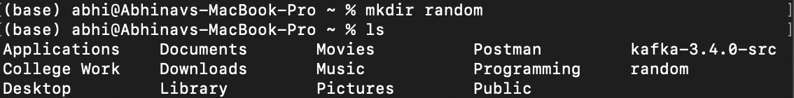

1. **mv <source-file> <destination-file>**

Moves a files/directory from the first argument destination to the second argument destination

Usage:

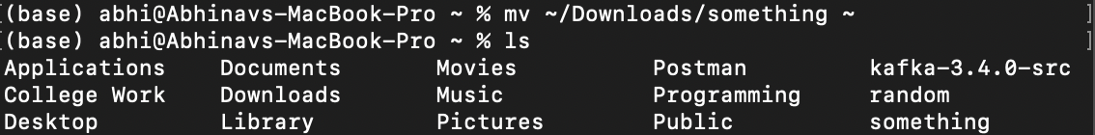

1. **rmdir <folder>**

Removes an empty directory from the current directory

Usage:

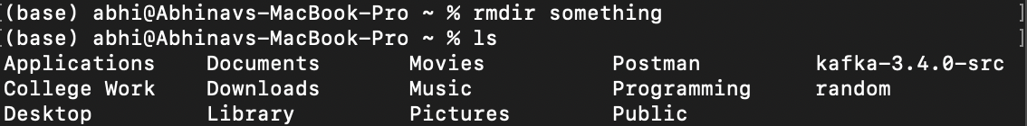

1. **cd <folder>**

Changes the directory to the directory given as an argument relative to the current directory

Usage:



1. **touch <filename>**

Creates a new file in the current directory and names it as the argument

Usage:



1. **nano <filename>**

Opens the file passed as arguments in the nano editor from the current directory

Usage:

1. **rm -r <folder>**

Recursively remove a folder and all its content from the current directory

Usage:

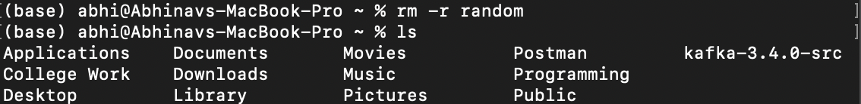

1. **pwd**

Display the current working directory’s absolute path

Usage:



1. **head <filename>**

Display the first 10 lines of a file in the current directory

Usage:

1. **tail <filename>**

Display the last 10 lines of a file in the current directory

Usage:

1. **cat <filename>**

Display the file given as arguments in the current directory

Usage:

1. **gzip <filename>**

Zip the filename given as arguments in the current directory

Usage:



1. **gunzip <filename>**

Unzip the filename given as arguments in the current directory

Usage:



1. **date**

Displays the current date

Usage:



1. **cal**

Displays the calendar with the date highlighted

Usage:

1. **clear**

Clears the terminal screen

Usage:

Before:

After:

1. **id**

Displays information about the current user id

Usage:

1. **cp <source-file> <destination-folder>**

Copy the given file from the first arguments to the second argument

Usage:



1. **chmod <+[rwx]/-[rwx]> <filename>**

Changes the given files permissions with options for reading, writing and being executable

Usage:



1. **sudo <command>**

Run a command as super user to bypass permissions set

Usage:

1. **od –[b/t/c] <filename>**

Display the content of a file in the given format from the current directory

Usage:

1. **sort <filename>**

Sort the content of a file by alphabetic order from the current directory

Usage: Same output, because contents are already sorted

1. **gzcat <filename>**

Display a gzipped file from the current directory

Usage:

1. **df**

Display the disk size used by files in the current directory

Usage:

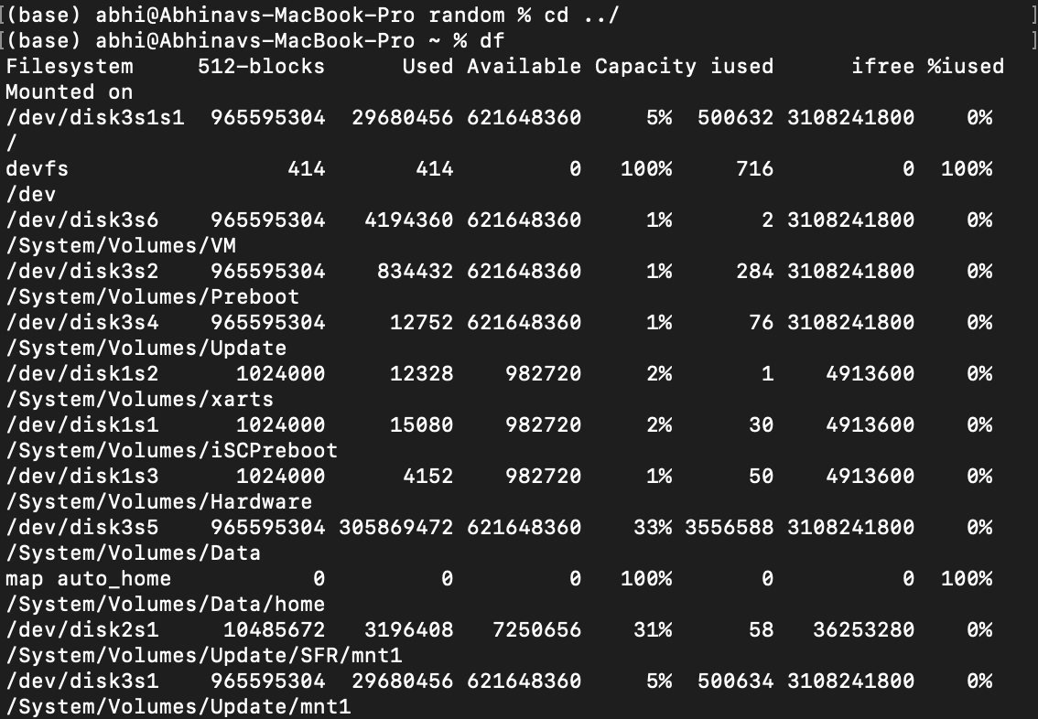

1. **date +%format**

Display a specific attribute of the date or in a specific format.

Usage:



1. **echo**

Display text given as an argument

Usage:



1. **bc**

API to access a basic calculator

Usage:

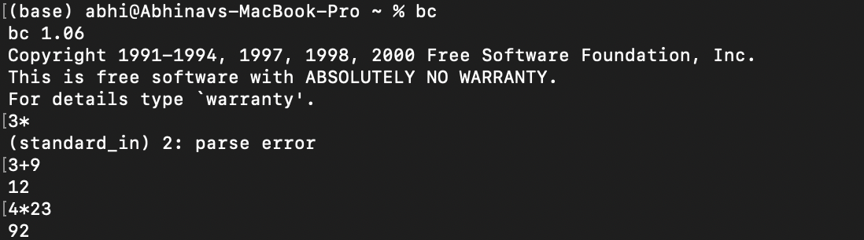

1. **who**

Displays information about the user

Usage:

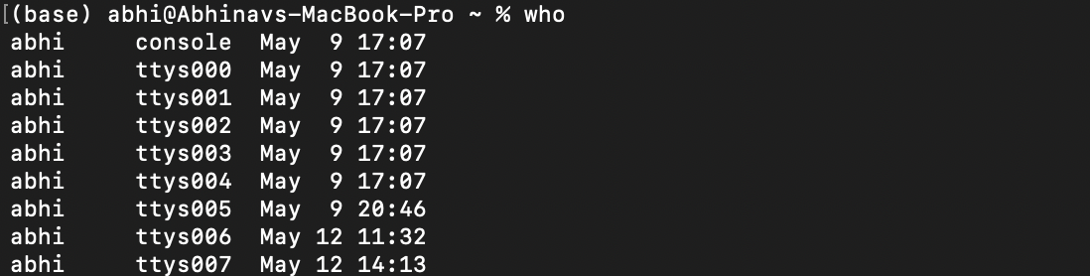

1. **finger**

Displays information about a specific user given as arguments.

Usage:

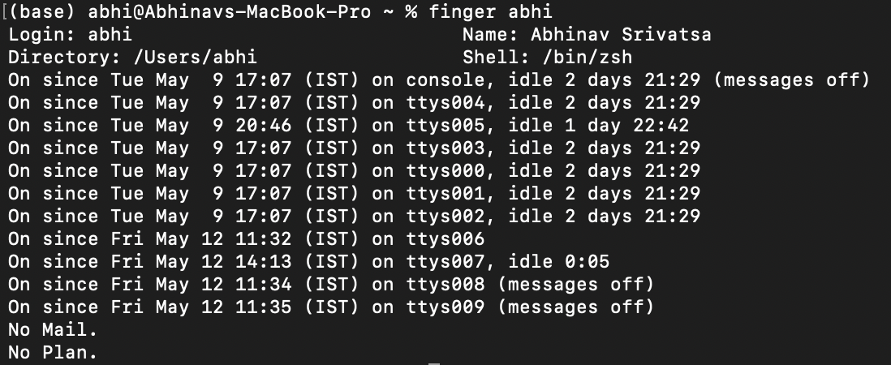

1. **id**

Displays information about a user related to user id and group id, this is for file/system permissions.

Usage:



1. **tty**

Displays the terminal file

Usage:

